**Assignment 8.2:**

**Problem Statement:**

Write a hive UDF that implements functionality of string concat_ws(string SEP, array<string>).

This UDF will accept two arguments, one string and one array of string.

It will return a single string where all the elements of the array are separated by the SEP.

Copying dataset from local file system to hadoop file system:



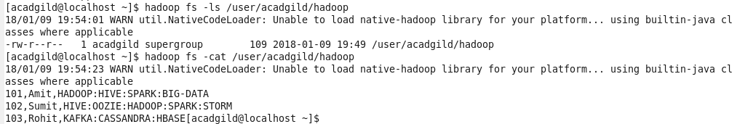

Creating employee hive table:

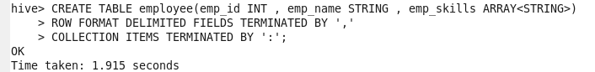

Loading dataset in to employee hive table:

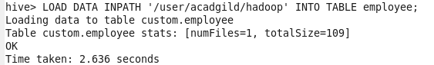

Checking contents of employee table:

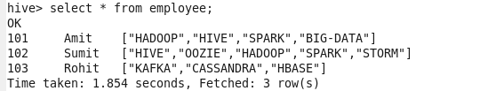

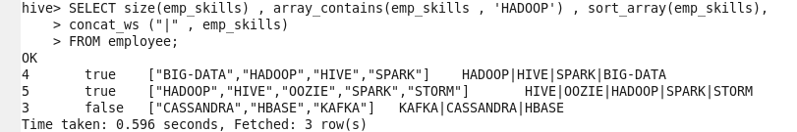

Exploding contents of an array:



Here AS clause is required as explode () is UDTF, which generates output as TABLE

**Output:**

Returned a single string where all the elements of the array are separated by the SEP:

